CMR TECHNICAL CAMPUS

Name:Ejjigani Sai karthik  
Roll Nmber:237R1A05U1  
Branch:Computer Science & Engineering  
Year:B.tech 2nd year

**Blockchain for Verifiable Digital  
Certification**

CMR TECHNICAL CAMPUS

**1. Introduction and Background on Certifications**

Certifications are formal recognitions of an individual’s skills, knowledge, or qualifications in a particular field. They are widely used in education, professional development, and various industries to validate competencies. Traditional certifications are often issued as physical documents or digital files, which can be susceptible to forgery, loss, or misrepresentation. With the rise of digital transformation, there is an increasing need for secure, transparent, and easily verifiable certification systems.

**2. Blockchain’s Role and Its Impact on Digital Certifications**

Blockchain is a decentralized, immutable, and secure ledger technology that enables transparent and tamper-proof record-keeping. Its application in digital certifications addresses several key challenges:

Security: Blockchain ensures that certifications cannot be altered or forged.

Transparency: All transactions, including issuance and verification, are recorded on the blockchain and are accessible to authorized parties.

Efficiency: Verification of credentials becomes instantaneous, eliminating the need for manual processes.

Ownership: Individuals have control over their certifications, which can be shared securely with employers or institutions.

How It Works:

Issuance: Institutions issue certifications as unique digital assets on the blockchain. Each certification is linked to a unique identifier (e.g., a hash).

Storage: The digital certificate is stored on the blockchain, ensuring immutability.

Verification: Anyone can verify the authenticity of the certificate by accessing the blockchain ledger.

Revocation: Institutions can revoke or update certificates if necessary, with all changes recorded transparently.

**3. Case Studies of Existing Blockchain-Based Certification Systems**

MIT Media Lab: MIT issues digital diplomas using the Blockcerts platform. These certifications are stored on the blockchain, allowing graduates to share and verify their credentials seamlessly.

IBM Digital Badges: IBM leverages blockchain to issue and manage digital badges for its training programs, ensuring credibility and ease of verification.

Singapore Government’s OpenCerts: OpenCerts is a blockchain-based platform used by educational institutions in Singapore to issue and verify academic certifications.

Learning Machine: A platform that collaborates with universities to issue verifiable blockchain-based diplomas and certificates.

**4. Comparison: Blockchain-Based Certifications vs. Traditional Systems**

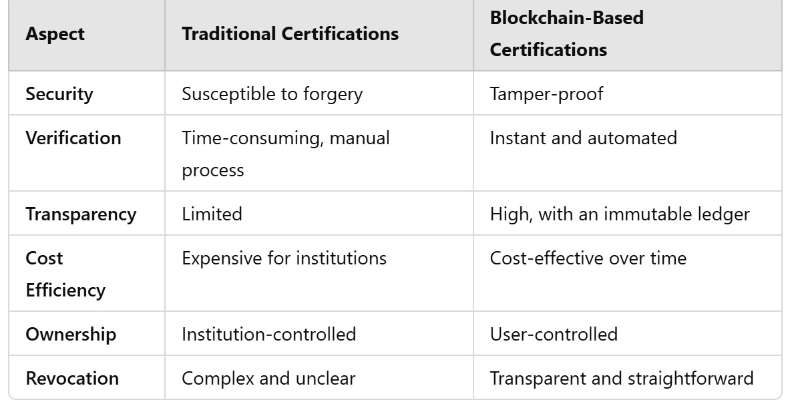

**5. Future Trends and Challenges**

**Future Trends:**

Integration with AI: AI can be used alongside blockchain to assess and issue certifications dynamically based on real-time performance metrics.

Interoperability: Development of standardized protocols for global adoption of blockchain-based certifications.

Credential Wallets: Digital wallets that allow users to store and manage multiple blockchain-based certifications.

Challenges:

Adoption and Awareness: Institutions and employers need to be educated on the benefits of blockchain-based systems.

Technical Expertise: Implementation requires significant technical knowledge and resources.

Data Privacy: Balancing transparency with compliance to privacy regulations like GDPR.

Scalability: Ensuring blockchain systems can handle a large volume of certifications efficiently.

**6. Conclusion**

Blockchain technology holds transformative potential for the issuance, verification, and management of digital certifications. By ensuring security, transparency, and efficiency, blockchain-based systems address the limitations of traditional methods. While challenges such as adoption and scalability remain, the future of digital certifications is undoubtedly intertwined with blockchain innovation, paving the way for a more trustworthy and efficient credentialing ecosystem.